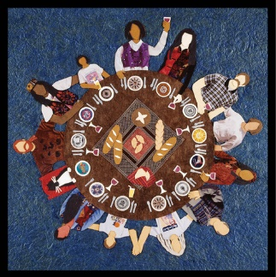
BRESLAU MENNONITE CHURCH
Sunday September 24, 2023

And we accept bread at his table, broken and shared, a living sign. Here in this world, dying and living, we are each other’s bread and wine. This is the place where we can receive what we need to increase: God’s justice and God’s peace.
What Is This Place #22 Voices Together

GATHERING IN FAITH AND WORSHIP
Prelude
Welcome
Call to Worship
Welcome to this place,
where we are fed from the word of God,
refreshed by the Spirit of God in prayer and song,
and restored by the loving and welcoming
presence of God in each other.
Gather around this table. All are welcome.
Gathering Prayer
Hymns All People That on Earth Do Dwell #5 VT
Draw the Circle #802 VT
Prayer of Thanksgiving – Giving Our First Fruit Offerings
Children’s Offering Project – BMC Food Drive
Collecting perishable food items

LEARNING AND GROWING TOGETHER

Children’s Story Dorothy H
Scripture Jeremiah 31:31-34; 1 Corinthians 11:23-26 #469 VT; Luke 22:14-30
Sermon Preparing the Table Pastor Eleanor
Hymn Here in This Place #10 VT
SHARING THE LOVE OF CHRIST IN COMMUNITY

Sharing Our Joys and Concerns
Praying Together
Hymn Let Us Break Bread Together #482 VT
Benediction
Postlude
VT Voices Together

Welcome!
Following the worship service
ALL are invited for coffee/tea and conversation.

Worship Leader Byron G
Accompanists Lynette G, Linden G
Choristers Allison D
Scripture Readers Jessa B, Byron G
Sound & Tech Bryan B
Greeter Kathy F
Ushers Sharon N, MJ B
Coffee Kathy F
Nursery Patti H

Ministers: All Persons in the Congregation
226 Woolwich Street South, Breslau ON N0B 1M0
519-648-2501 www.breslaumc.ca

Pastor Eleanor Epp-Stobbe (she/her) eleanor@breslaumc.ca
Children, Youth & Young Adult Coordinator Amanda Snyder (she/her)
amanda@breslaumc.ca
Administrative Assistant Doris Gingerich office@breslaumc.ca
Office Hours Tuesdays & Thursdays: 10am-2pm
BMC phone & email are regularly checked.

Elders Janet A Nick B Pat K
Jean LE Justin M Jeremy R

