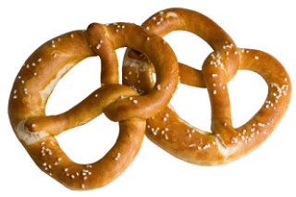
Prayer Pretzels

In prayer we talk with God, we can tell God our needs, our fears, and our hopes.
When early Christians would pray, they would cross their arms and touch each shoulder with the opposite hand. This pretzel dough can be formed like praying arms or hands held in prayer. Enjoy!
- Warm 1 cup milk to 110 degrees (feels warm on wrist) in a medium-sized glass or microwavable bowl.
- Sprinkle 1 Tablespoon of yeast over it to soften for a few minutes.
- Whisk in 3 T. brown sugar and 1 cup all-purpose flour.
- Dice and soften 2 T. butter. Add with 1.25 cup more flour and
1 teaspoon salt to dough mixture.
- Mix in bowl with hands and add a bit more flour as you knead it together. Knead a few more minutes until mixture is elastic but forms a ball. Cover and let rise in an oven with the oven light on (or a warm space) for almost an hour to double size.
- Preheat oven to 450 degrees F. Mix one third cup baking soda with
2 cups warm water in a container for pretzel dipping.
- Cover cookie sheets with parchment paper or grease.
- Flatten dough with rolling pin into a rectangle about 16”x8”x0.5” thickness. With a sharp knife slice dough lengthwise into 5-7 strips. Roll or squeeze into a snake shape and then form into a pretzel shape.
- Dip in soda water, sprinkle with coarse salt and bake 8-10 minutes until they are golden.

