[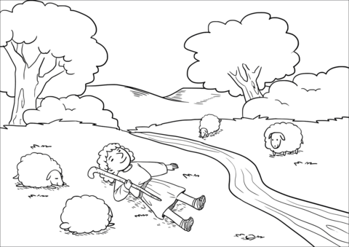](http://www.supercoloring.com/coloring-pages/the-lord-makes-me-lie-down-in-green-pastures?version=print)