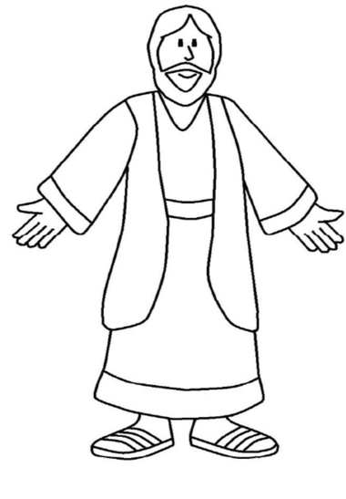

FLAT JESUS
I am always with you.
Matthew 28:20
Flat Jesus reminds us that Jesus is with us always, you are not alone. We want to keep Jesus at the centre of our lives, especially when we cannot be physically together as a church family.
Colour and decorate me, then carefully cut me out, maybe add something hard to my back. Glue or tape on a popsicle stick to my back, that makes me easier to hold.
Take me with you on a bike ride or walk, when you read or play games, on a picnic or when you help make a meal, when you are alone or with your family.
Take me with you on your summer adventures – wherever you go, whatever you do!
Take a picture and include Flat Jesus too.
Send your pictures to office@breslaumc.ca
You and Flat Jesus will be posted on our church website. www.breslaumc.ca
This project is for EVERYONE!

